package assistedprojectjava;

class Myclasses1 {

int a,b;

void get(int x,int y) {

a=x;

b=y;

}

void disp() {

System.***out***.println("classes and objects");

System.***out***.println(a);

System.***out***.println(b);

}

}

public class MyClassessss {

public static void main(String[] args) {

Myclasses1 m=new Myclasses1(),m1=new Myclasses1();

m.get(100,200);

m1.get(300,400);

m.disp();

m1.disp();

// **TODO** Auto-generated method stub

}

}

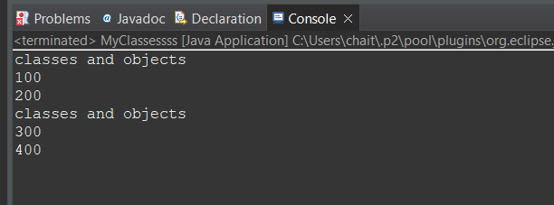

package assistedprojectjava;

class Sum {

public int calculateSum(int a, int b) {

return a + b;

}

}

// inheriting from Sum

class SumExtended extends Sum {

*@Override*

public int calculateSum(int a, int b) {

return super.calculateSum(a, b) * 2;

}

}

public class Polymorphism {

public static void main(String[] args) {

Sum sum1 = new Sum();

Sum sum2 = new SumExtended();

int result1 = sum1.calculateSum(2, 3);

System.***out***.println("Result from Sum class: " + result1);

int result2 = sum2.calculateSum(2, 3);

System.***out***.println("Result from SumExtended class: " + result2);

// **TODO** Auto-generated method stub

}

}

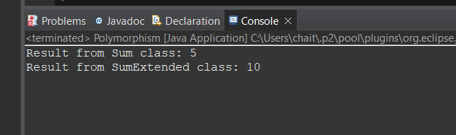

package assistedprojectjava;

class Vehicle {

private String brand;

private String model;

private int year;

// Constructor

public Vehicle(String brand, String model, int year) {

this.brand = brand;

this.model = model;

this.year = year;

}

public String getBrand() {

return brand;

}

public void setBrand(String brand) {

this.brand = brand;

}

public String getModel() {

return model;

}

public void setModel(String model) {

this.model = model;

}

public int getYear() {

return year;

}

public void setYear(int year) {

this.year = year;

}

// Method to display vehicle information

public void display() {

System.***out***.println("Brand: " + brand);

System.***out***.println("Model: " + model);

System.***out***.println("Year: " + year);

}

}

// inheriting from Vehicle

class Car extends Vehicle {

private int numDoors;

// Constructor

public Car(String brand, String model, int year, int numDoors) {

super(brand, model, year);

this.numDoors = numDoors;

}

// Getter and Setter methods for numDoors

public int getNumDoors() {

return numDoors;

}

public void setNumDoors(int numDoors) {

this.numDoors = numDoors;

}

public void display() {

super.display();

System.***out***.println("Number of doors: " + numDoors);

}

}

// class to demonstrate inheritance

public class Inheritance {

public static void main(String[] args) {

// Creating an object of the Car class

Car car = new Car("Maruti Suzuki", "Dzire", 2023, 3);

System.***out***.println("Car brand: " + car.getBrand());

car.setModel("Swift");

System.***out***.println("Updated car model: " + car.getModel());

System.***out***.println("Car year: " + car.getYear());

car.setYear(2020);

System.***out***.println("Updated car year: " + car.getYear());

System.***out***.println("Number of doors: " + car.getNumDoors());

car.setNumDoors(2);

System.***out***.println("Updated number of doors: " + car.getNumDoors());

// Displaying information about the car

car.display();

// **TODO** Auto-generated method stub

}

}

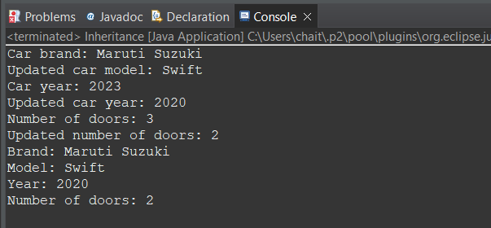

package assistedprojectjava;

class Person {

private String name;

private int age;

// Getter and Setter methods for name

public String getName() {

return name;

}

public void setName(String name) {

this.name = name;

}

// Getter and Setter methods for age

public int getAge() {

return age;

}

public void setAge(int age) {

if (age >= 0 && age <= 120) {

this.age = age;

} else {

System.***out***.println("Invalid age!");

}

}

}

// class to demonstrate encapsulation

public class Encapsulation {

public static void main(String[] args) {

// Creating an object of the Person class

Person person = new Person();

// Setting values using setter methods

person.setName("chaitanya");

person.setAge(23);

// Accessing values using getter methods

System.***out***.println("Name: " + person.getName());

System.***out***.println("Age: " + person.getAge());

// **TODO** Auto-generated method stub

}

}

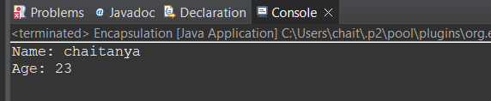

package assistedprojectjava;

abstract class Animal {

abstract void makeSound();

}

class Dog extends Animal {

void makeSound() {

System.***out***.println("Woof");

}

}

class Cat extends Animal {

void makeSound() {

System.***out***.println("Meow");

}

}

public class Abstraction {

public static void main(String[] args) {

Animal myDog = new Dog();

Animal myCat = new Cat();

myDog.makeSound();

myCat.makeSound();

// **TODO** Auto-generated method stub

}

}

